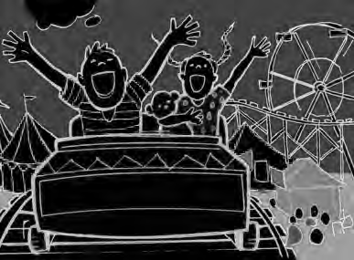

















Finding the Main Idea
Saturday at the Carnival

James and his sister, Anna, went to the carnival on Saturday. They rode the merry- go-round, the roller coaster and the Ferris wheel. James
ate popcorn and a hot dog. Anna drank lemonade and
ate an apple. They saw many exciting shows. They were tired when they went home.

What is the main idea? Circle the correct answer. A. James and Anna were hungry.
B. James and Anna did many things at the carnival. C. The merry-go-round was broken.
D. The carnival was on Saturday.

Write three details in the story in the boxes.

2 3

Finding the Main Idea
Saturday at the Carnival

James and his sister, Anna, went to the carnival on Saturday. They rode the merry- go-round, the roller coaster and the Ferris wheel. James
ate popcorn and a hot dog. Anna drank lemonade and
ate an apple. They saw many exciting shows. They were tired when they went home.

What is the main idea? Circle the correct answer. A. James and Anna were hungry.
B. James and Anna did many things at the carnival. C. The merry-go-round was broken.
D. The carnival was on Saturday.

Write three details in the story in the boxes.

Actual answers and wording will vary. Example of correct answers:

2 3

James and Anna rode the roller coaster.
James ate a hot dog. They saw shows.

