

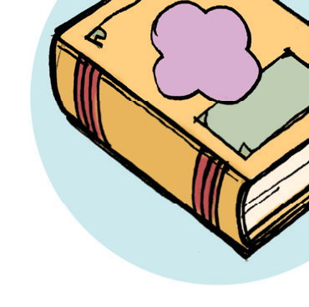

Name:

My Favorite Book

What is your favorite book? In the space below, tell about your favorite book. What is the book about? Why do you like it? Why is it better than others?

Copyright © 2013 K12reader.com. All Rights Reserved. Free for educational use at home or in classrooms. www.k12reader.com

