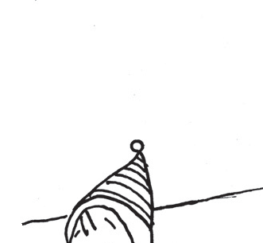








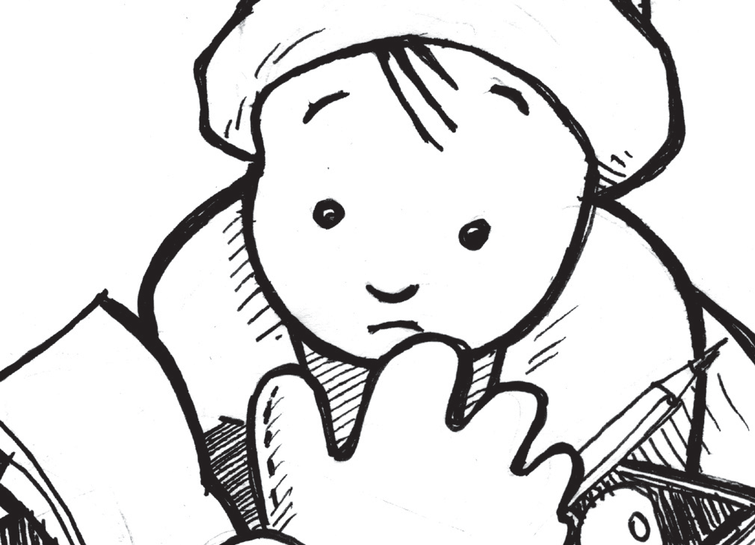







Name:
Finish the Snowman: Tell the Story

It snowed last night. The children are building a snowman. They have found some funny things in a box to put on the snowman. With pictures and words, tell a story of
how the children ﬁnish the snowman. What things do they use from the box to put on the snowman? When you are ﬁnished, you may color the ﬁrst pictures.

How will we ﬁnish our snowman with only that box of funny things?

Copyright © 2013 K12reader.com. All Rights Reserved. Free for educational use at home or in classrooms. www.k12reader.com

