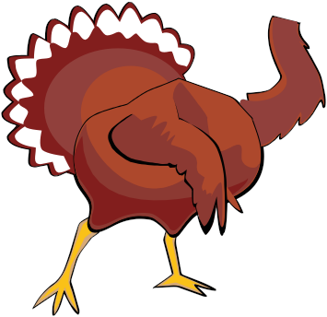



NAME: _________________________

Help Tom Turkey
ﬁnd the letter T!
Color highlight (yellow) each letter T below

K T I O J K T L

N | R | D | F | T | F | J | K
V | T | B | N | B | T | X | C
H | T | R | H | T | R | H | F
N | B | Z | X | C | T | K | T
T | M | O | D | T | R | T | Y
I | O | T | F | G | H | J | T
H | T | J | F | T | G | T | N
T | H | G | T | R | E | R | W
F | G | T | U | W | C | G | T

Help Tom Turkey
ﬁnd the letter T!
ircle each letter T below

K T I O J K T L

N R D F T F J K V T B N B T X C H T R H T R H F N B Z X C T K T T M O D T R T Y I O T F G H J T H T J F T G T N T H G T R E R W F G T U W C G T

