Name:

Word Detective: The Ugly Duckling



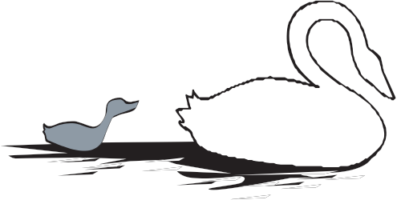
Hans Christian Andersen wrote the story of “The Ugly Duckling.” It tells about a small baby duck, called a duckling, who is a very ugly duck. He
is not very happy because all the farm animals make fun of him. Then, one day the duckling grows up. He finds out he is not a duck, but a beautiful swan!

Below is part of the story.

The poor duckling, had crept out of his shell last of all. He looked so ugly! He was bitten and pushed and made fun of, not only by the
ducks, but by all the poultry. “He is too big,” they all said. The turkey, who fancied himself really
an emperor, puffed himself out like a vessel in full sail. He flew at the duckling, and became quite red in the face with passion. The poor little duckling did not know where to go. He was quite
miserable because he was so ugly and laughed at by the whole farmyard. So it went on from day to day till it got worse and worse. The poor duckling was driven about by every one; even his brothers and sisters were unkind to him. They would say, “Ah, you ugly creature, I wish the cat would get you.” The ducks pecked him, the chickens beat him, and the girl who fed the poultry kicked him with her feet. So at last he ran away, frightening the little birds in the hedge as he flew off.
Circle the letter of the word that means almost the same thing as the underlined word. Use the rest of the sentence to
help find the correct meaning of the word.

1. “...made fun of, not only by the ducks, but by all the poultry.”
A. vegetables B. birds C. clouds

2. “The turkey, who fancied himself really an emperor...”
A. ran B. dressed C. believed

3. “...puffed himself out like a vessel in full sail.”
A. ship B. cake C. goose

4. “...became quite red in the face with passion...”
A. sunrise B. rain C. anger

5. “was quite miserable because he was so ugly and laughed at...”
A. calm B. unhappy C. hungry

6. “...even his brothers and sisters were unkind to him...”
A. mean B. helpful C. asleep

7. “...would say, ‘Ah, you ugly creature, I
wish the cat would get you.’” A. door B. animal C. apple

8. “So at last he ran away, frightening the little birds...”
A. writing B. feeding C. scaring

Name: Key

Word Detective: The Ugly Duckling

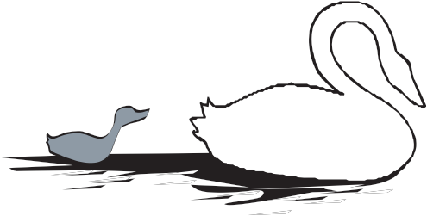
Hans Christian Andersen wrote the story of “The Ugly Duckling.” It tells about a small baby duck, called a duckling, who is a very ugly duck. He
is not very happy because all the farm animals make fun of him. Then, one day the duckling grows up. He finds out he is not a duck, but a beautiful swan!

Below is part of the story.

The poor duckling, had crept out of his shell last of all. He looked so ugly! He was bitten and pushed and made fun of, not only by the
ducks, but by all the poultry. “He is too big,” they all said. The turkey, who fancied himself really
an emperor, puffed himself out like a vessel in full sail. He flew at the duckling, and became quite red in the face with passion. The poor little duckling did not know where to go. He was quite
miserable because he was so ugly and laughed at by the whole farmyard. So it went on from day to day till it got worse and worse. The poor duckling was driven about by every one; even his brothers and sisters were unkind to him. They would say, “Ah, you ugly creature, I wish the cat would get you.” The ducks pecked him, the chickens beat him, and the girl who fed the poultry kicked him with her feet. So at last he ran away, frightening the little birds in the hedge as he flew off.
Circle the letter of the word that means almost the same thing as the underlined word. Use the rest of the sentence to
help find the correct meaning of the word.

1. “...made fun of, not only by the ducks, but by all the poultry.”
A. vegetables B. birds C. clouds

2. “The turkey, who fancied himself really an emperor...”
A. ran B. dressed C. believed

3. “...puffed himself out like a vessel in full sail.”
A. ship B. cake C. goose

4. “...became quite red in the face with passion...”
A. sunrise B. rain C. anger

5. “was quite miserable because he was so ugly and laughed at...”
A. calm B. unhappy C. hungry

6. “...even his brothers and sisters were unkind to him...”
A. mean B. helpful C. asleep

7. “...would say, ‘Ah, you ugly creature, I
wish the cat would get you.’” A. door B. animal C. apple

8. “So at last he ran away, frightening the little birds...”
A. writing B. feeding C. scaring

