Money, Money, Everywhere!

Cross-Curricular Focus: Mathematics

Money helps us buy things we need and want. People earn money by working at all different kinds of jobs. You can earn money even if you are a child. Your parents may pay you to do extra chores around the house.
If you have money, you can use it for many things. You can pay bills. You can buy things from stores. You can save it in the bank. Before people had money to use, they traded things with each other. Some people used beads or shells for money.
Paper money is also called dollars. The numbers on
the paper money tell how many dollars it is worth. If

Name:

Answer the following questions based on the reading passage. Don’t forget to go back to the passage whenever necessary to ﬁnd or conﬁrm your answers.

1) How do people earn money?

2) What can we do with money?

3) What did people use before there was money?

it has a one on it, it is a one dollar bill. Five, ten, and

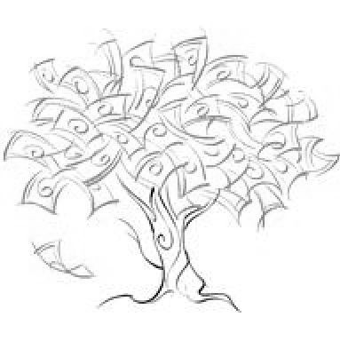
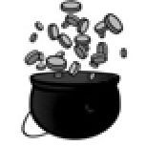
twenty dollar bills are also common.
Coins are made from different kinds of metal. They are worth part of a dollar. There are dollar coins but they are rare. Amounts less than a whole dollar are counted
in cents. It takes 100 cents to make a dollar. Each coin is worth a different number of cents. A penny is worth only 1 cent. A nickel is worth 5 cents. A dime is worth 10 cents. A quarter is worth 25 cents.

4) How can you tell how much paper money is worth?

5) How do we count money that is less than a whole dollar?

Money, Money, Everywhere!

Cross-Curricular Focus: Mathematics

Name:
Key

Money helps us buy things we need and want. People earn money by working at all different kinds of jobs. You can earn money even if you are a child. Your parents may pay you to do extra chores around the house.
If you have money, you can use it for many things. You can pay bills. You can buy things from stores. You can save it in the bank. Before people had money to use, they traded things with each other. Some people used beads or shells for money.
Paper money is also called dollars. The numbers on the paper money tell how many dollars it is worth. If
it has a one on it, it is a one dollar bill. Five, ten, and twenty dollar bills are also common.
Coins are made from different kinds of metal. They are worth part of a dollar. There are dollar coins but they are rare. Amounts less than a whole dollar are counted
in cents. It takes 100 cents to make a dollar. Each coin
is worth a different number of cents. A penny is worth

Answer the following questions based on the reading passage. Don’t forget to go back to the passage whenever necessary to ﬁnd or conﬁrm your answers.

Actual answers may vary.

1) How do people earn money?
by working at different jobs

2) What can we do with money?
pay bills or buy things or save it

3) What did people use before there was money?
They traded things or used
shells or beads.

4) How can you tell how much paper money is worth?
the number on the paper money

5) How do we count money that is less than a

only 1 cent. A nickel is worth 5 cents. A dime is worth 10 cents. A quarter is worth 25 cents.
whole dollar?
cents

