Cross-Curricular Reading Comprehension Worksheets: C-16 of 36

Phases of the Moon

Name:
Key

Cross-Curricular Focus: Earth Science

Have you noticed that sometimes the moon looks like a tiny sliver of light in the night sky? Other times it is a big, brilliant circle. The moon has many different looks during the month. Each look is called a lunar phase. Lunar means “of the moon.” The moon has phases because it orbits Earth. The Earth revolves around the sun. The moon revolves separately around Earth. The moon itself does not actually change size. It appears to change size because different parts of it are in the shadow. The shadow is caused by the sun’s light hitting Earth.
In the new moon phase, none of the part of the moon that is facing Earth is lit by the sun. It appears as only a dark outline. During the waxing crescent phase, the moon is small. Only a
tiny sliver of the moon’s side that is facing Earth is lit by the sun. The next phase is the first quarter phase. In it, half of the moon’s nearest side is lit by the sun. We see it as about one-fourth of a full moon. During the waxing gibbous phase, more of the moon is lit. Even so, it is not quite a full moon yet. In the full moon phase, all of the side of the moon that is facing Earth is lit by the sun.
It appears as a large, bright circle. During the waning gibbous phase, some of the part that was lit as a full moon begins to fall into the shadows. In the last quarter phase, a different side of the moon is lit. Again, the moon appears as one-fourth full. During
the waning crescent phase, the moon slips further into shadows.

Actual wording of answers may vary.
Answer the following questions based on the reading passage. Don t forget to go back to the passage whenever necessary to find or confirm your answers.

1) What is meant by a “phase” of the moon?
different looks

2) Why does the moon appear to be different sizes?
because of the rotation of the Earth and the moon

3) What are the two phases during which the moon appears almost full, but not quite?
waxing gibbous and waning gibbous

4) What are the two phases during which the moon appears as only a tiny sliver?
waxing crescent and waning crescent

5) What is your favorite phase of the moon? Why?
student’s choice

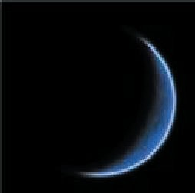
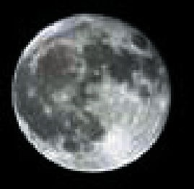
It is a thin crescent shape once more. After this phase, the entire
lunar cycle begins again with a new moon.

Cross-Curricular Reading Comprehension Worksheets: C-16 of 36

Phases of the Moon

Name:
Key

Cross-Curricular Focus: Earth Science

Have you noticed that sometimes the moon looks like a tiny sliver of light in the night sky? Other times it is a big, brilliant circle. The moon has many different looks during the month. Each look is called a lunar phase. Lunar means “of the moon.” The moon has phases because it orbits Earth. The Earth revolves around the sun. The moon revolves separately around Earth. The moon itself does not actually change size. It appears to change size because different parts of it are in the shadow. The shadow is caused by the sun’s light hitting Earth.
In the new moon phase, none of the part of the moon that is facing Earth is lit by the sun. It appears as only a dark outline. During the waxing crescent phase, the moon is small. Only a
tiny sliver of the moon’s side that is facing Earth is lit by the sun.
Actual wording of answers may vary.
Answer the following questions based on the reading passage. Don t forget to go back to the passage whenever necessary to find or confirm your answers.

1) What is meant by a “phase” of the moon?
different looks

2) Why does the moon appear to be different sizes?
because the moon orbits the earth

3) What are the two phases during which the moon appears almost full, but not quite?
waxing gibbous and waning gibbous

The next phase is the first quarter phase. In it, half of the moon’s
nearest side is lit by the sun. We see it as about one-fourth of a

full moon. During the waxing gibbous phase, more of the moon is lit. Even so, it is not quite a full moon yet. In the full moon phase, all of the side of the moon that is facing Earth is lit by the sun.
It appears as a large, bright circle. During the waning gibbous phase, some of the part that was lit as a full moon begins to fall into the shadows. In the last quarter phase, a different side of the moon is lit. Again, the moon appears as one-fourth full. During
the waning crescent phase, the moon slips further into shadows.
4) What are the two phases during which the moon appears as only a tiny sliver?
waxing crescent and waning crescent

5) What is your favorite phase of the moon? Why?
student’s choice

It is a thin crescent shape once more. After this phase, the entire
lunar cycle begins again with a new moon.

