Name

Christmas Tree Add an Adjective

Write an adjective from the list in each blank. You may only use an adjective once.

There is a star at the top.

The lights on the tree are

We hung

ornaments on the tree.

The candy canes on the tree look

Adjective List
sweet shiny four tall

pretty blue wonderful silver

round yummy six
short green

big bright red
beautiful gold


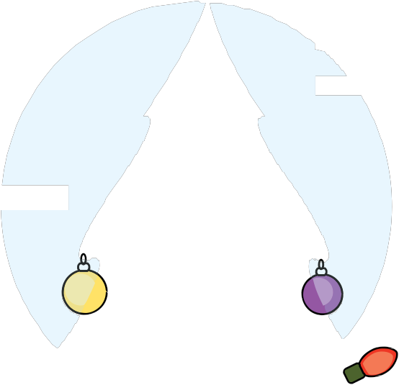
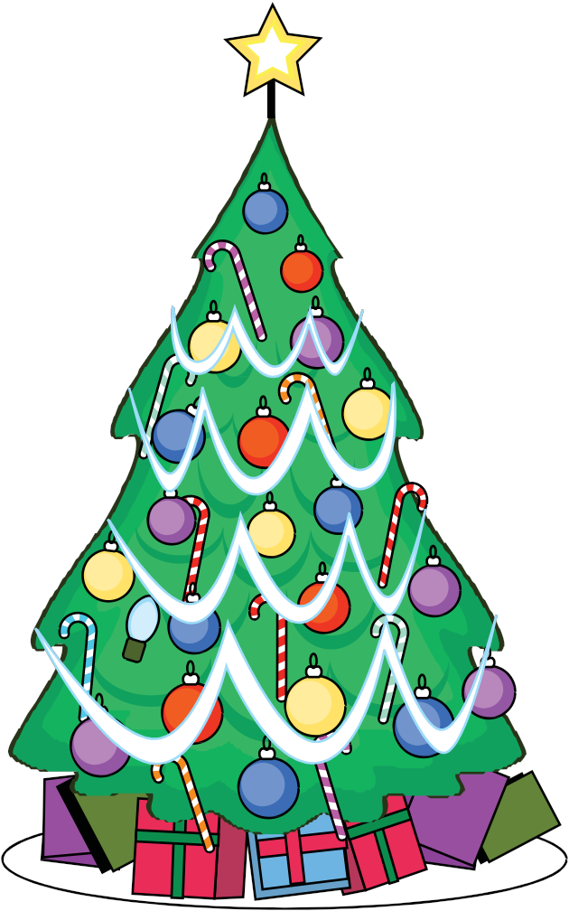

Copyright © 2012 K12reader.com. All Rights Reserved. Free for educational use at home or in classrooms. www.k12reader.com

