Name:

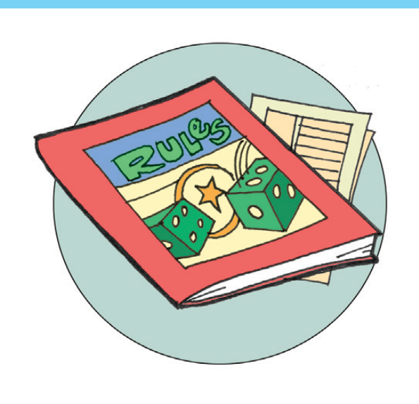

RULES OF THE GAME

Explain the rules of a game. It can be any kind of game, such as

a sport, a card game or a board game. Explain it so that someone who has never played it will understand it. Be sure and include what kind of equipment is needed. There is also a space for you to add pictures.

Copyright © 2013 K12reader.com. All Rights Reserved. Free for educational use at home or in classrooms. [www.k12reader.com](http://www.k12reader.com/)