Name:

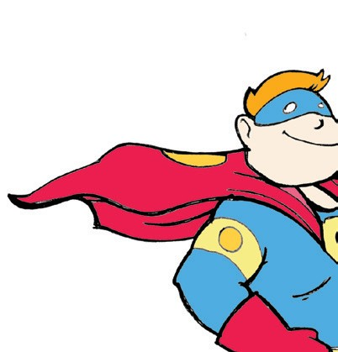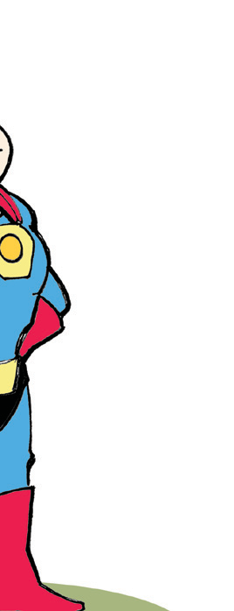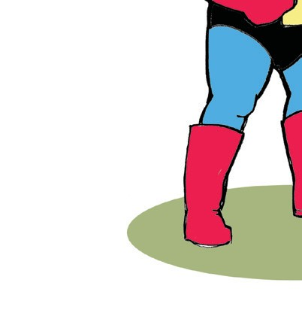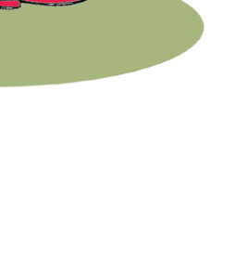

I’m a Superhero!

Imagine you are given the power of a superhero. What would be your special power? Why would you want it? What would you do with this new ability?

Copyright © 2013 K12reader.com. All Rights Reserved. Free for educational use at home or in classrooms. [www.k12reader.com](http://www.k12reader.com/)