What Do You

See?

Name:

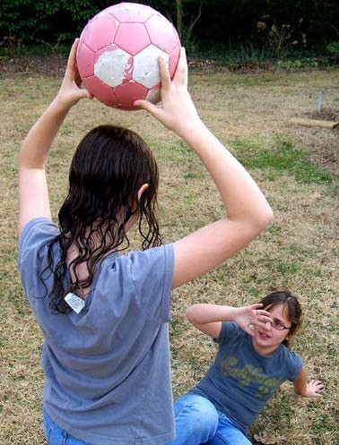

Look at the picture carefully, then answer the questions below.

**1. What do you think is happening in the picture?**

What details in the picture make you think this?

**2. How do you think the girl on the ground is feeling?**

Explain your answer and include details from the picture.

**3. What time of year do you think it is? Explain your answer.**

What Do You

See?

Name:

Answers



Look at the picture carefully, then answer the questions below.

Actual student responses will vary. Example of correct answers:

**1. What do you think is happening in the picture?**

What details in the picture make you think this?

The standing girl is threatening to throw the ball at the girl

on the ground. She is holding the ball above her head. The girl on the ground is trying to protect herself by holding her arm in front of her face.

**2. How do you think the girl on the ground is feeling?**

Explain your answer and include details from the picture.

The girl on the ground is afraid. She is holding her arm in front of her face so the ball won’t hurt her. She’s not

smiling or laughing, so it’s not a game.

**3. What time of year do you think it is? Explain your answer.**

It might be fall or spring. The grass is mostly brown, but some of it is green. Both girls are wearing t-shirts, so it can’t be very cold.