How Things Move

Cross-Curricular Focus: Physical Science

We can watch things around us move. When something is in **motion**, it **changes** its position. Objects can move from one place to another. They can move in many directions. I f you roll a ball, it might move in a straight line. It might also move in a curve. A swing can move back and forth. A light

switch can move up and down. Fans have blades that move in a circle.

If you want to know if something is moving, you can compare it to other things around it that are not moving. I f the things behind the object are

changing, the object is probably moving. If they are not changing, the object is probably not moving.

You can measure the motion of an object. Just

measure the distance between where it was when it

Cross-Curricular Reading Comprehension Worksheets: B-3 of 36

**Name:**

**Answer the following questions based on the reading passage. Don’t forget to go back to the passage whenever necessary to ﬁnd or conﬁrm your answers.**

1) When something is in motion, what does it change?

2) How does a swing move?

3) How does a light switch move?

4) How can you test if something is moving or not?

started to move and where it was when it stopped.

Distance can be measured in inches, feet, yards or miles. Those measurements are in the customary system. It can also be measured in millimeters, centimeters, meters and kilometers. Those measurements are in the metric system.

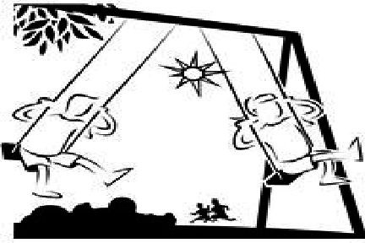

5) What is one unit of measurement you could use to measure distance?

Cross-Curricular Reading Comprehension Worksheets: B-3 of 36

How Things Move

Cross-Curricular Focus: Physical Science

**Name:**

key



We can watch things around us move. When something is in **motion**, it **changes** its position. Objects can move from one place to another. They can move in many directions. I f you roll a ball, it might move in a straight line. It might also move in a curve. A swing can move back and forth. A light

switch can move up and down. Fans have blades that move in a circle.

If you want to know if something is moving, you can compare it to other things around it that are not moving. I f the things behind the object are

changing, the object is probably moving. If they are not changing, the object is probably not moving.

You can measure the motion of an object. Just measure the distance between where it was when it started to move and where it was when it stopped. Distance can be measured in inches, feet, yards or miles. Those measurements are in the customary system. It can also be measured in millimeters, centimeters, meters and kilometers. Those measurements are in the metric system.

**Answer the following questions based on the reading**

**passage. Don’t forget to go back to the passage whenever necessary to ﬁnd or conﬁrm your answers.** Actual answers may vary.

1) When something is in motion, what

does it change?

position

2) How does a swing move?

back and forth

3) How does a light switch move?

up and down

4) How can you test if something is moving or not? You compare it to objects around it that are not moving.

5) What is one unit of measurement you could use to measure distance? inches, feet, miles or meters, etc.