Name:

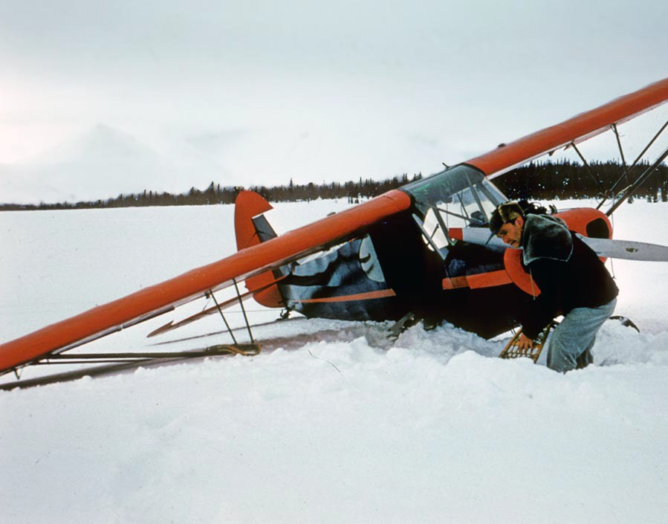

Using Inference in Writing

riters use inference in their text to make their writing more interesting. It’s not necessary to tell the reader every detail. Instead, let them

W

draw their own conclusions about what is happening.

Look at the picture on the right. A man is using a snowshoe to dig the airplane out of the snow. Write a short story describing what is happening in the picture. You may use any point of view you like. However,

you cannot use the words snow, airplane, or plane. You want readers to draw their own conclusion on what is happening without you telling them explicitly.

Name:

**KEY**



Using Inference in Writing

riters use inference in their text to make their writing more interesting. It’s not necessary to tell the reader every detail. Instead, let them

W

draw their own conclusions about what is happening.

Look at the picture on the right. A man is using a snowshoe to dig the airplane out of the snow. Write a short story describing what is happening in the picture. You may use any point of view you like. However,

you cannot use the words snow, airplane, or plane. You want readers to draw their own conclusion on what is happening without you telling them explicitly.

**Student’s Choice**