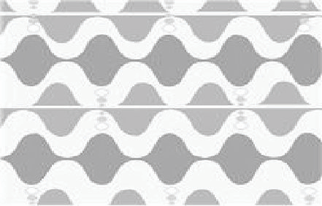
Waves & Currents
Cross-Curricular Focus: Physical Science

When you hear the words wave and currents, your brain might immediately make you think about the ocean. They at least make you think about some form of water. That’s natural. That’s probably where you have heard those two words used most. But waves and currents can also be talking about energy.
Energy travels in waves. Waves can be in the water, but they can also be on land or in the air. A wave moves energy from one place to another. Light, sound and mechanical energy all travel in waves.
Sound waves are made by the vibration of tiny particles we can’t see. Plucking a string on a guitar makes the air around the string move back and forth.
A wave can be measured. To measure a wave, we look at its highest point (crest) and lowest point (trough). The distance from one trough to the next is called its wavelength. You can time the number of crests that happen in one minute. That will tell you the frequency of a wave.
An electric current is the constant ﬂow of electric energy. The constant ﬂow of charged particles is an electric current. Tiny particles with a negative charge move toward those with a positive charge. Electric current needs an unbroken path, or circuit. A circuit is made of wires, an energy source and something that uses energy. When they are connected in a circuit, the current can ﬂow!
Name:

Answer the following questions based on the reading passage. Don’t forget to go back to the passage whenever necessary to ﬁnd or conﬁrm your answers.

1) Use your existing connections to the words waves and currents to help you connect to their new meanings. What do ocean waves and currents have to do with energy waves and electrical currents?

2) Give an example of a kind of energy that travels in waves.

3) What is the difference between a trough and a crest?

4) What is a wavelength?

5) What is a circuit made of?

Waves & Currents

Name:

Cross-Curricular Focus: Physical Science

When you hear the words wave and currents, your brain might immediately make you think about the ocean. They at least make you think about some form of water. That’s natural. That’s probably where you have heard those two words used most. But waves and currents can also be talking about energy.
Energy travels in waves. Waves can be in the water, but they can also be on land or in the air. A wave moves energy from one place to another. Light, sound and mechanical energy all travel in waves.
Sound waves are made by the vibration of tiny particles we can’t see. Plucking a string on a guitar makes the air around the string move back and forth.
A wave can be measured. To measure a wave, we look at its highest point (crest) and lowest point (trough). The distance from one trough to the next is called its wavelength. You can time the number of crests that happen in one minute. That will tell you the frequency of a wave.
An electric current is the constant ﬂow of electric energy. The constant ﬂow of charged particles is an electric current. Tiny particles with a negative charge move toward those with a positive charge. Electric current needs an unbroken path, or circuit. A circuit is made of wires, an energy source and something that uses energy. When they are connected in a circuit, the current can ﬂow!

Answer the following questions based on the reading passage. Don’t forget to go back to the passage whenever necessary to ﬁnd or conﬁrm your answers.
1) Use your existing connections to the words waves and currents to help you connect to their new meanings. What do ocean waves and currents have to do with energy waves and electrical currents?
2) Give an example of a kind of energy that travels in waves.

3) What is the difference between a trough and a crest?
4) What is a wavelength?

5) What is a circuit made of?

